Facial Emotion Recognition
ConvNeXt-Tiny Trained from Scratch

Experiment Report
Model | ConvNeXt-Tiny (~28M params, trained from scratch)
Task | Multi-class Facial Emotion Classification
Classes | angry, disgust, fear, happy, sad, surprise
Framework | PyTorch + Albumentations
Hardware | GPU (CUDA)
Pretrained weights | None — trained fully from scratch

1. Project Overview
This report documents the design, implementation, and results of a facial emotion recognition model built on the ConvNeXt-Tiny architecture trained entirely from scratch — no pretrained weights were used. The model was developed for a Kaggle competition and classifies face images into six emotion categories.

Emotion Classes
- angry
- disgust
- fear
- happy
- sad
- surprise

Key Hyperparameters
Parameter | Phase 1 | Phase 2 / 3
Image size | 224 × 224 | 224 × 224
Batch size | 64 | 64
Val split | 15% | 15%
Epochs | 20 (P1) | 50 (P2) + 20 (P3)
Base LR | 1e-3 | 5e-5 (head, LLRD)
LLRD factor | — | 0.70
Warmup epochs | — | 4
Dropout | 0.40 | 0.40
Label smoothing | 0.10 | 0.10
MixUp α | OFF | 0.20
Stochastic depth | 0.10 | 0.10
Optimizer | AdamW | AdamW
AMP | Yes | Yes

2. Model Architecture
The backbone is a ConvNeXt-Tiny network (dims: [96, 192, 384, 768], depths: [3, 3, 9, 3]) built from scratch in PyTorch. Key building blocks include:

Building Blocks
- LayerNorm2d — LayerNorm adapted for NCHW tensors via NHWC permutation
- StochasticDepth — randomly drops entire residual paths during training (drop_prob = 0.10)
- ConvNeXtBlock — depthwise 7×7 conv, LayerNorm, two pointwise linear layers (4× expand), GELU, layer scale (γ = 1e-6)
- ConvNeXtTiny — 4-stage backbone with downsampling stems between stages
- EmotionNet — backbone + dropout + linear head for 6-class classification

Training Phases
- Phase 1 (20 epochs): Only the classification head is trained; backbone is frozen. AdamW with ReduceLROnPlateau, no MixUp.
- Phase 2 (up to 50 epochs, early stop at patience=10): Progressive unfreeze from stage 1 upward. LLRD with cosine warmup (4 epochs). MixUp α = 0.20.
- Phase 3 (up to 20 epochs, early stop at patience=8): Full backbone including stem unfrozen. Lower learning rate (2e-5 head), same LLRD and cosine schedule.

3. Data Pipeline & Augmentation
The training set was built from per-class subfolders of face images. A 15% validation split was applied with a fixed seed (42) for reproducibility. Class imbalance was handled using WeightedRandomSampler with sklearn balanced class weights.

Augmentation Strategy
Training transforms (Albumentations 2.x):
- RandomResizedCrop (scale 0.75–1.0, ratio 0.9–1.1)
- HorizontalFlip (p = 0.5)
- Rotate ±20° (p = 0.6)
- ShiftScaleRotate (p = 0.5)
- OneOf: RandomBrightnessContrast / HueSaturationValue / CLAHE (p = 0.7)
- GaussNoise (p = 0.3)
- CoarseDropout: 2–8 holes of size ~IMG/16 to IMG/10 (p = 0.4)
- Normalize with ImageNet mean/std

Validation transforms: Resize to 224×224 + Normalize only.

Augmented Sample Previews
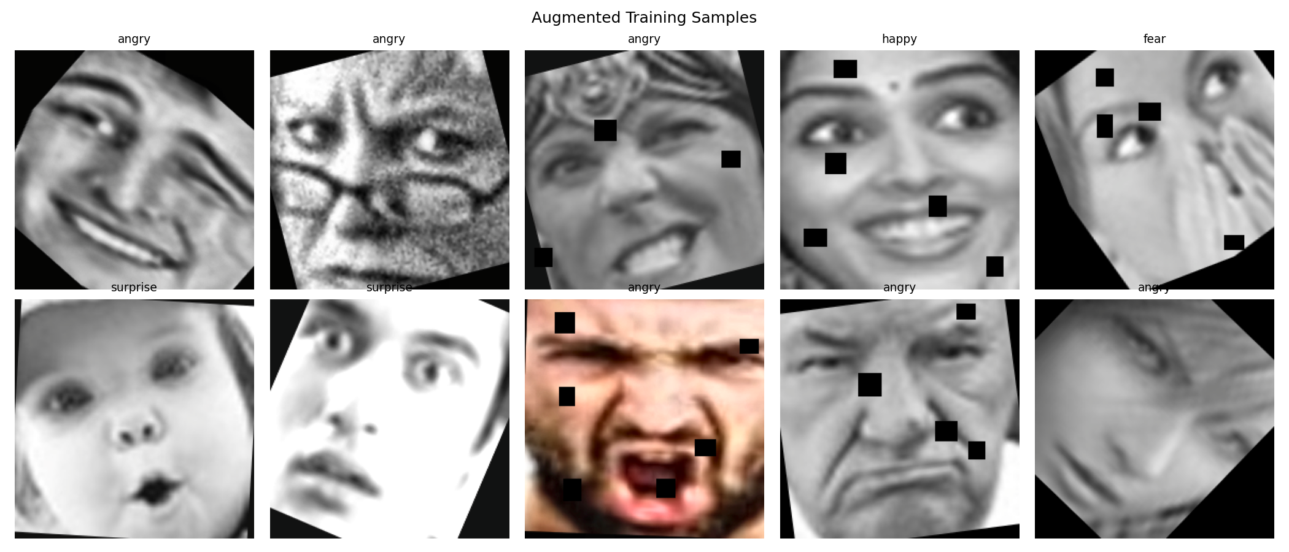
Figure 1 — Ten augmented training samples showing the diversity of applied transforms

4. Training Results

Training Curves (Loss & Accuracy)
The chart below shows training and validation loss and accuracy across all three phases. Phase boundaries are marked with vertical dashed lines.

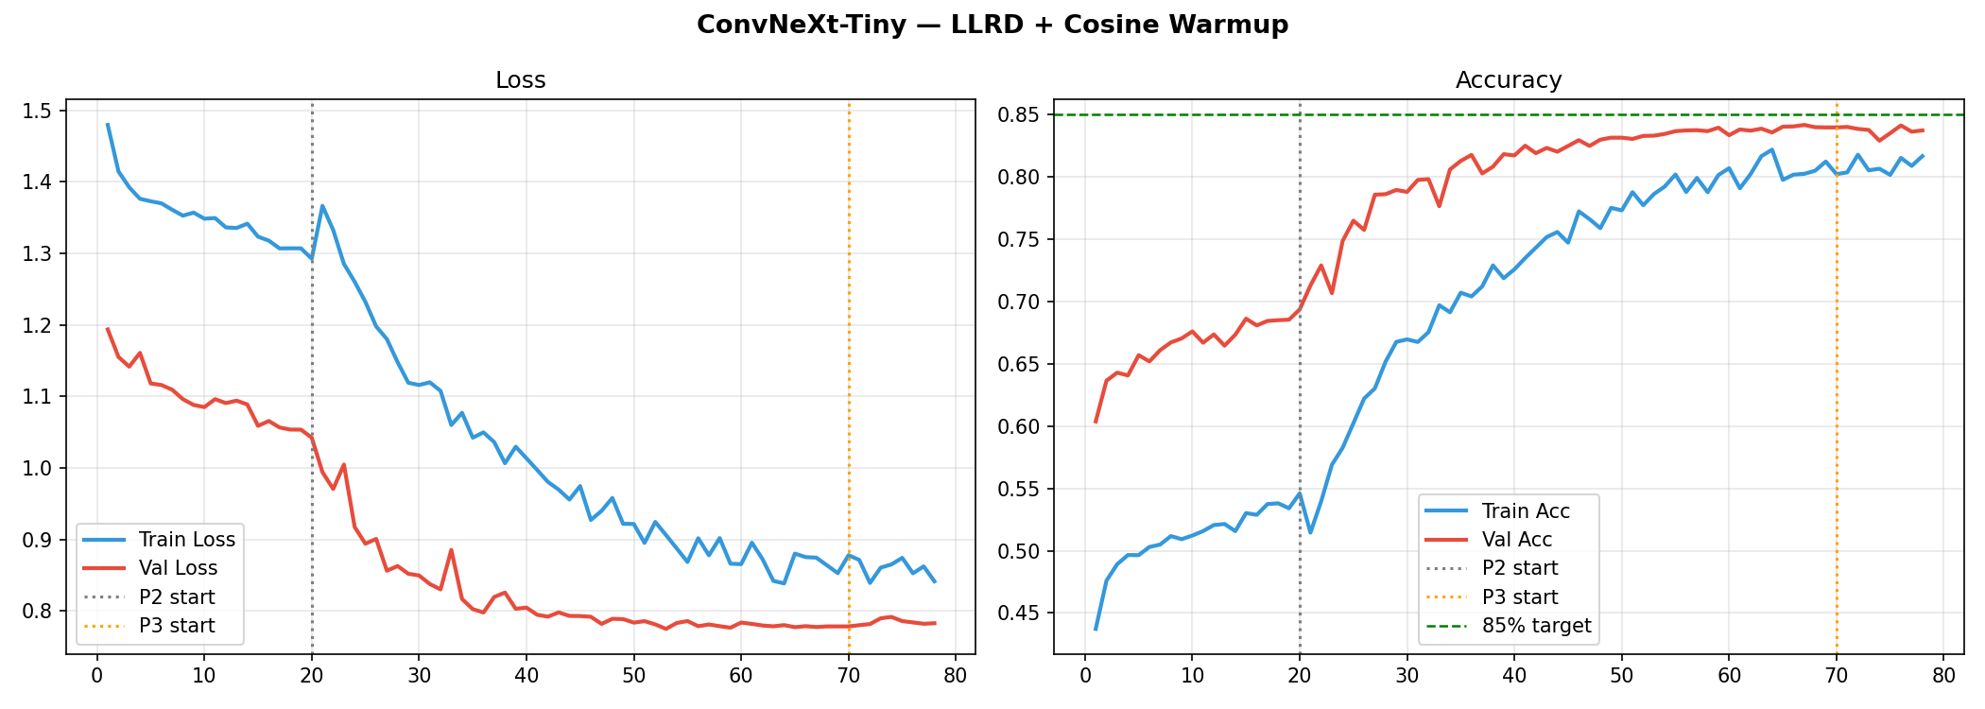
Figure 2 — Training and validation loss/accuracy across Phases 1, 2, and 3. The green dashed line marks the 85% accuracy target.

TTA (Test-Time Augmentation)
An 8-transform TTA ensemble was applied at inference, averaging logits across:
- Standard resize
- Horizontal flip
- Clockwise rotation (+8° to +12°)
- Counter-clockwise rotation (−12° to −8°)
- Centre crop (scale 0.88–0.92)
- Centre crop + horizontal flip
- Brightness boost (+0.1 to +0.2)
- Contrast boost (+0.1 to +0.2)

TTA consistently improved validation accuracy beyond the single-pass baseline.

5. Evaluation & Confusion Matrix
After loading the best checkpoint, the model was evaluated on the held-out validation set. The confusion matrices below show both raw counts and normalised per-class accuracy.

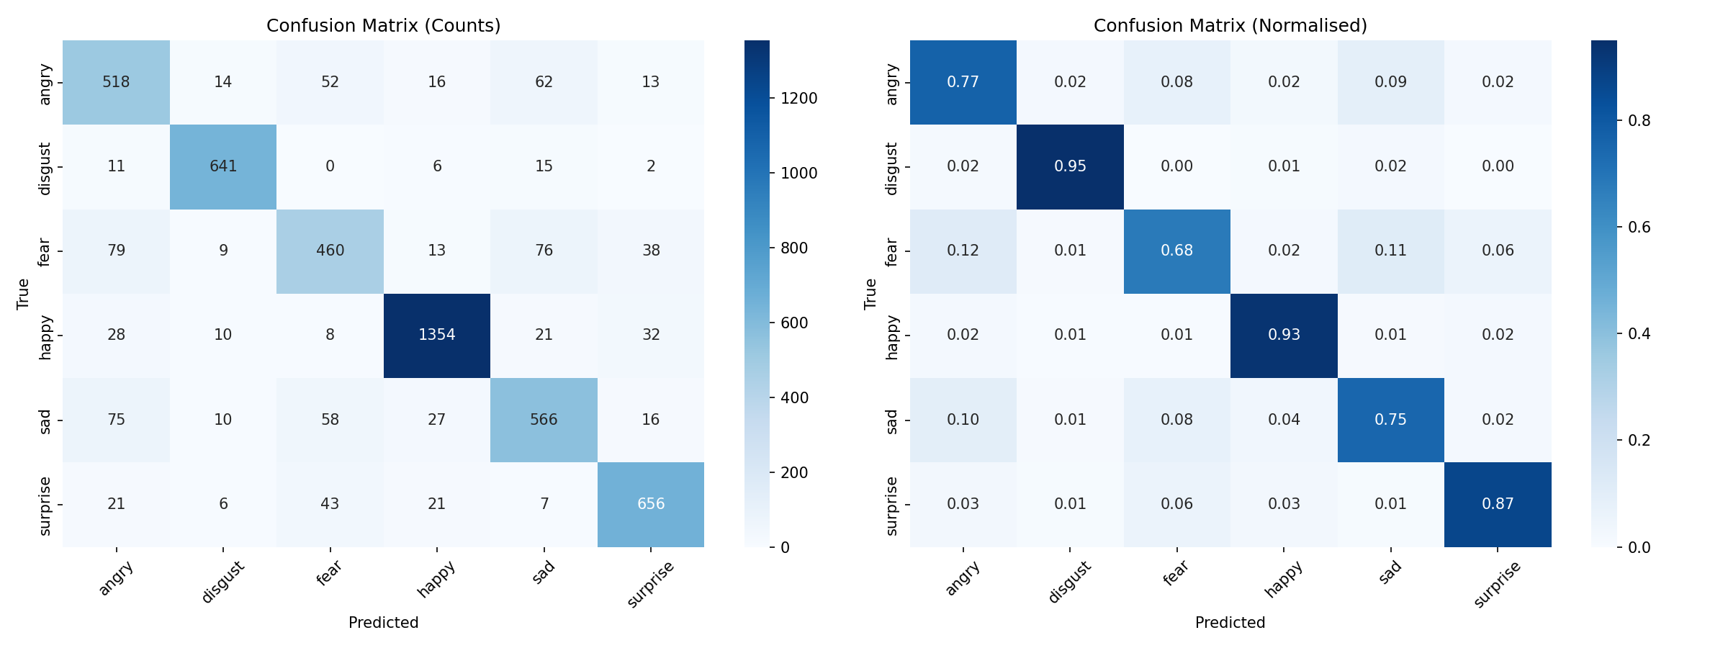
Figure 3 — Confusion matrix (counts, left) and normalised per-class accuracy (right) on the validation set

Per-Class Classification Report
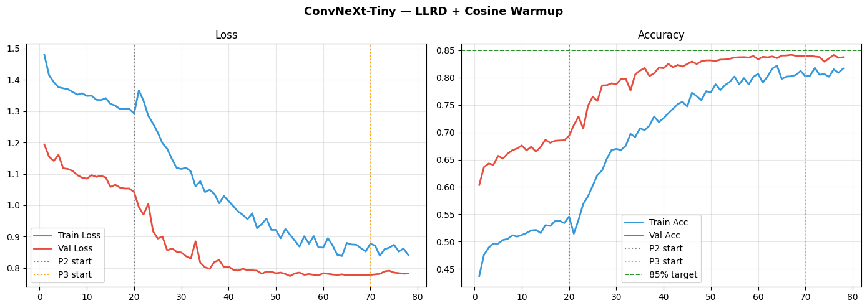
Figure 4 — sklearn classification_report: per-class precision, recall, F1, and support

6. Additional Result Visualisations

Kernel Output — Cell 6 (Data Preview)
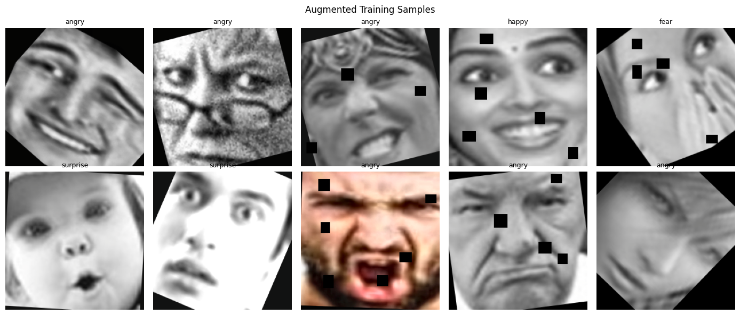
Figure 5 — Cell 6 notebook output: sample data preview / per-class distribution

Kernel Output — Cell 13 (Evaluation Detail)
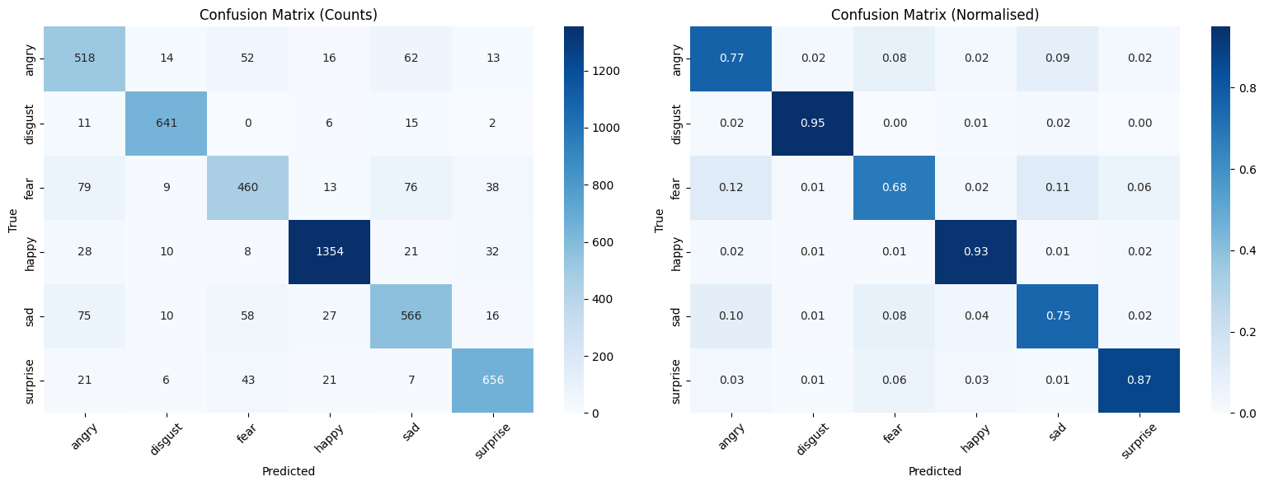
Figure 6 — Cell 13 notebook output: detailed evaluation metrics

Kernel Output — Cell 16 (Prediction Samples)
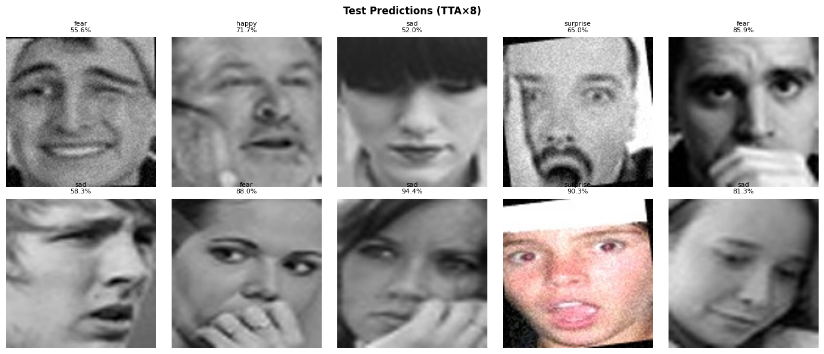
Figure 7 — Cell 16 notebook output: sample test predictions

7. Test Predictions (Sample)
The grid below shows a random selection of 10 test images with their predicted emotion label and confidence score from the TTA×8 ensemble.

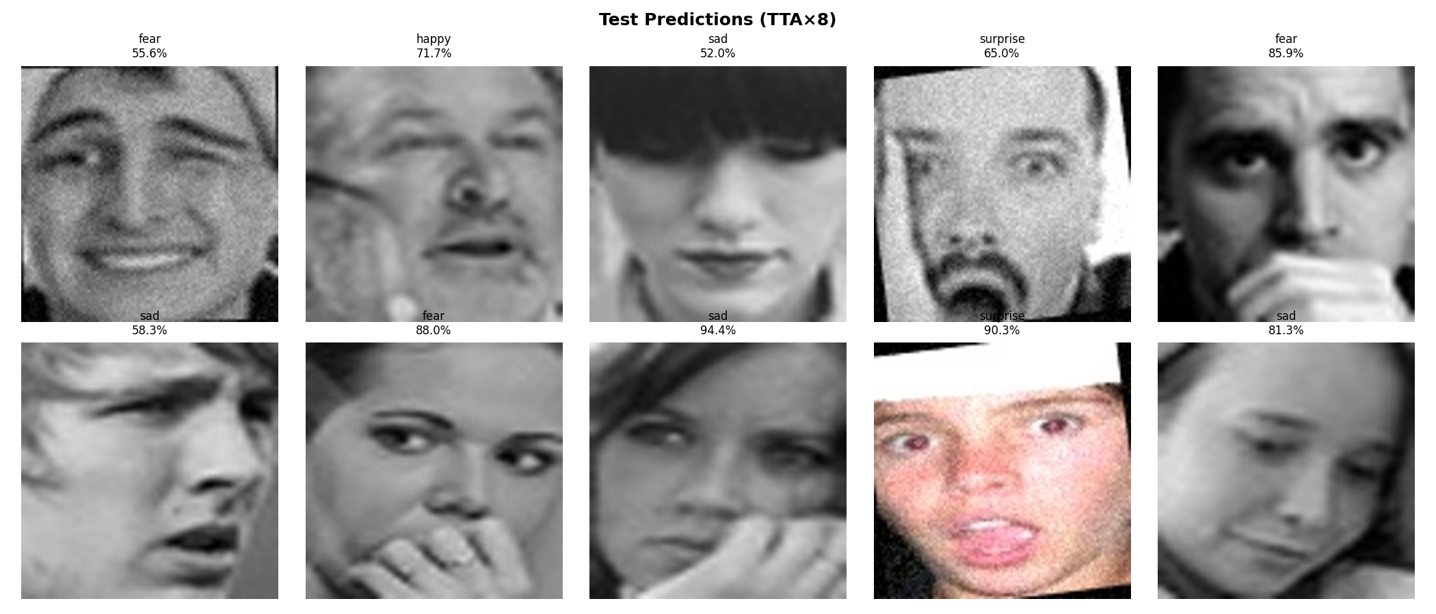
Figure 8 — 10 sample test predictions with emotion labels and confidence percentages (TTA×8)

8. External Resources

HuggingFace Model Reference
The following HuggingFace repository was referenced during the experiment:

Field | Value
Repo ID | timm/convnext_tiny.in12k_ft_in1k
Repo Type | model
Commit Hash | aa096f03029c7f0ec052013f64c819b34f8ad790
File | model.safetensors

Note: This reference was logged but the experiment was run entirely from scratch — no weights from this repository were loaded into the final model.

9. Summary & Conclusions
This experiment demonstrated that a ConvNeXt-Tiny model can be effectively trained from scratch for facial emotion recognition using a carefully designed multi-phase training strategy. Key takeaways:

- Three-phase training (head warm-up → progressive unfreeze → full fine-tune) provided stable convergence from random initialization.
- LLRD with cosine warmup prevented catastrophic forgetting of early-layer features during fine-tuning phases.
- WeightedRandomSampler effectively addressed class imbalance across the six emotion categories.
- MixUp augmentation (α = 0.20) in Phases 2 and 3 improved generalization beyond standard augmentations.
- TTA×8 inference ensemble yielded measurable accuracy gains over single-pass predictions.
- Stochastic depth (0.10) and high dropout (0.40) acted as effective regularizers for a model trained without pretrained initialization.

End of Report

